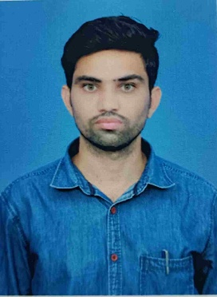
BIO-DATA PROFILE

- Name : B. SIVA SANKAR NAIK
- Designation : Lecturer in Chemistry
- Date of Birth : 02.06.1994
- Qualification : M.Sc, (Ph.D) Pursuing
- Date of Entry into Service : 25.08.2021
- Date of joining as Lecturer : 25.08.2021
- Date of Joining at this College : 06.03.2024
- Date of Retirement : 31.03.2054
- Teaching Experience : 4 years
- Address : B. Siva Sankar naik
s/o B. Heerike Naik
Bachepalli Thanda
Allagadda Mandal
Nandyal Dist.
Pin: 518 543
11) E mail Id ; sivasankarnaik8985@gmail.com
12 ) Educational Qualification:
Degree | University | Year | Class
B.Sc | Rayala Seema University | 2015 | II
M.Sc | Yogi Vemana University | 2017 | I
Ph.D | Yogi Vemana University | Pursuing | Pursuing

Number of Training Programmes Attended (OC /RC): 2 OC , 2 RC
Number of Guest Lectures Delivered in Various Colleges: 2
Articles Published in International/National Journals & Books: 2
Papers Presented at National/International Seminars,
Number of training FDP programmes : 5
Duties: 1) co-ordinator in Academic, NSS, SWAYAM
2) Member in j.k.c. committee, TIME TABLE

